JENNA DEPELLEGRINI
E-PORTFOLIO
(412) 980- 7867 | jennadepell0411@gmail.com

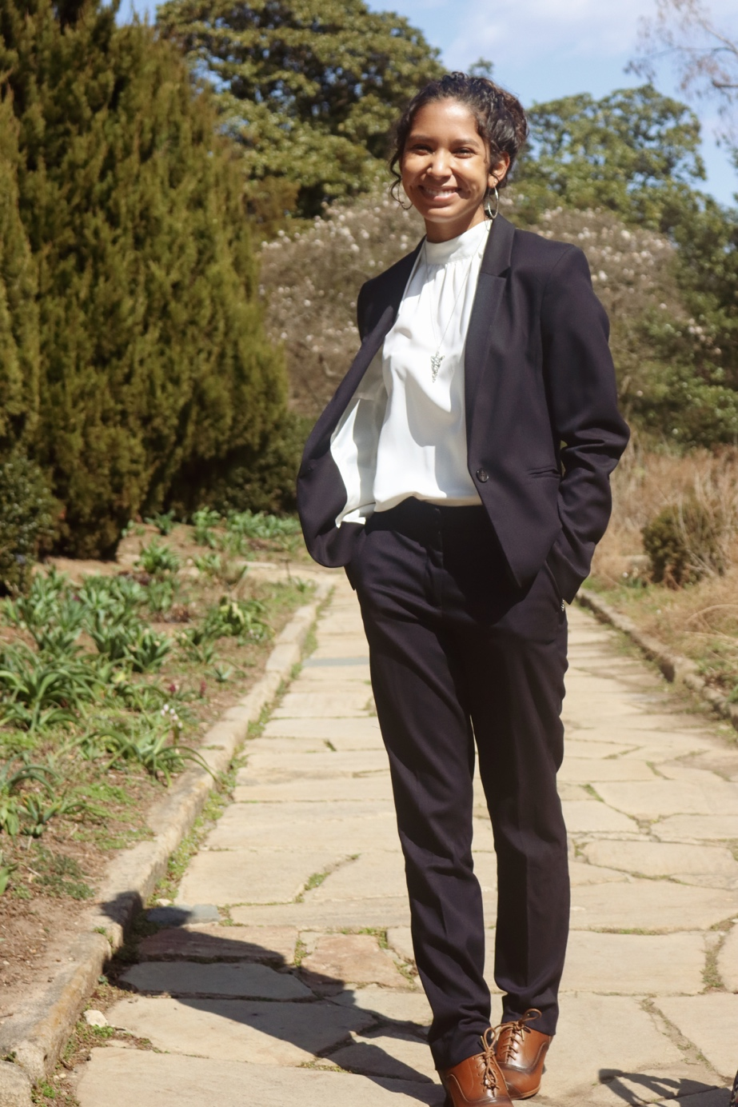

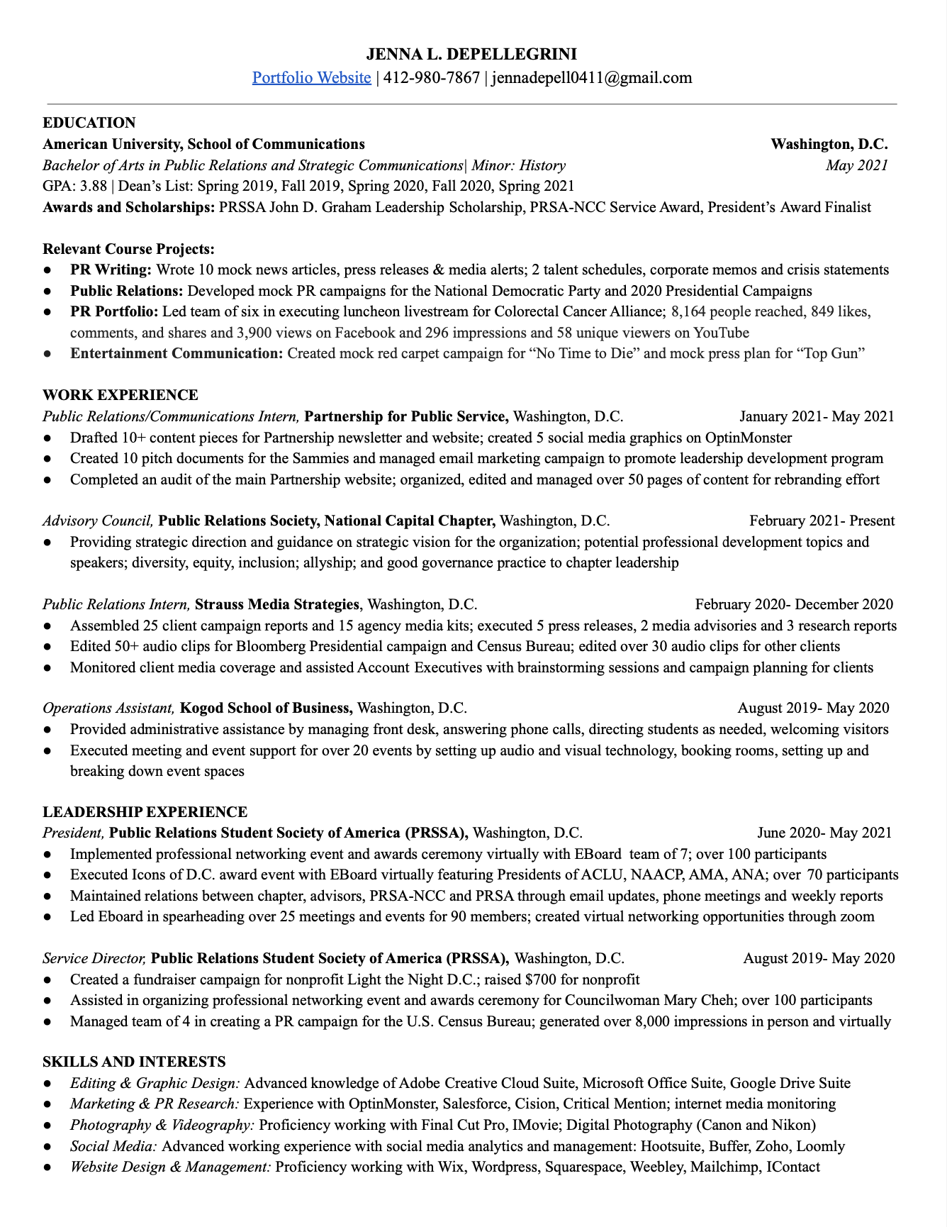

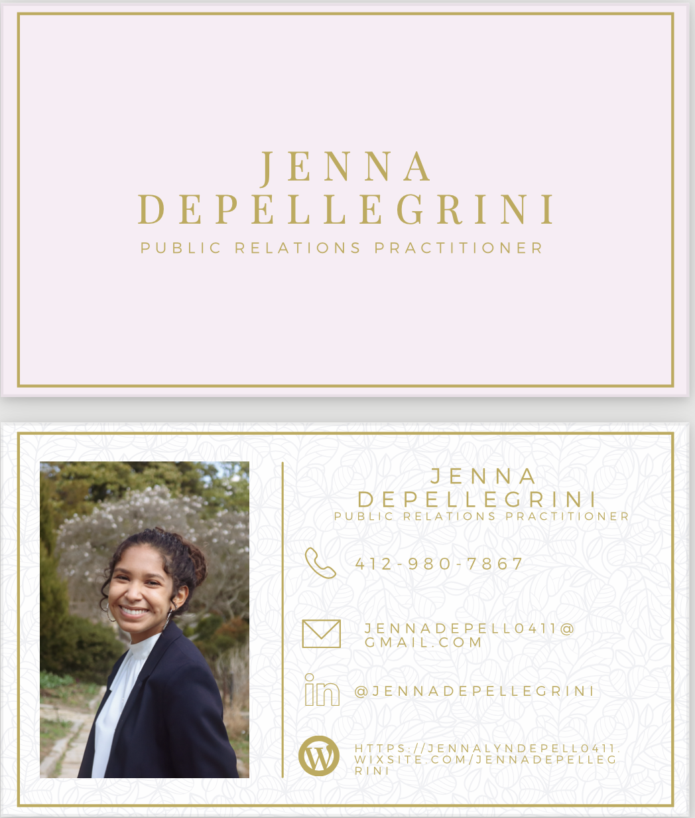
FOR IMMEDIATE RELEASE

COLORECTAL CANCER ALLIANCE PARTNERS WITH STUDENTS TO HOST “BLUE BAG” LUNCHEON ON FRIDAY, MARCH 5, 2021

Luncheon Dedicated to Chadwick Boseman and Survivors of Colorectal Cancer: Take the Pledge to Get Screened

(WASHINGTON, D.C.-- January 31, 2021) The Colorectal Cancer Alliance is virtually with American University Students Against Colorectal Cancer to host a “Blue Bag” Luncheon on Friday, March 5, 2021.The luncheon, being hosted on Facebook Live, is dedicated in part to late actor Chadwick Boseman and other survivors battling colorectal cancer as part of an initiative to get Americans to take the pledge to get screened.

“Dress in Blue Day is a celebration of colorectal cancer awareness and we want to impart the importance of getting screened to our allies and contributors,” said CEO Michael
Sapienza. “We also want to recognize and support survivors of colorectal cancer and those currently undergoing the fight against it.”

Statistics show that colorectal cancer is the third most diagnosed cancer in both men and women within the U.S. However, less than 50% of Americans were screened for colorectal cancer in 2019, despite young onset rates rising in the past two years. With this event, the Alliance aims to help expand awareness of young onset colorectal cancer and the symptoms and treatment options of colorectal cancer to the American people.

This luncheon will include statements from CEO Sapienza, Director of Screening Trudy Loper and Director of Community Engagement Ali Miller, along with pre-recorded words from the President of Howard University, Wayne A. I. Frederick and actress Phylicia Rashad. Participants will also hear from survivors and engage in a brief Q&A session with Dr. Mohamed Salem of Georgetown University Hospital.

The “Blue Bag” luncheon will also remember the legacy of late actor Chadwick Boseman who lost his life to colorectal cancer in 2020. Boseman served as an inspiration for others to make a difference and helped the Alliance empower a nation of allies to provide genuine support for patients and families, caregivers, and survivors.

# # #

The Colorectal Cancer Alliance is a national nonprofit committed to ending colorectal cancer. Working with our nation of passionate allies, we diligently support the needs of patients and families, caregivers, and survivors; eagerly raise awareness of preventative screening; and continually strive to fund critical research. As allies in the struggle, we are fiercely determined to end colorectal cancer within our lifetime. For more information, please visit ccalliance.org.

FOR IMMEDIATE RELEASE

MICHELLE OBAMA PARTNERS WITH GIRL SCOUTS TO LAUNCH NEW COOKIE: JAM SESSION NATIONWIDE ON TUESDAY, APRIL 21, 2020

All Proceeds from the First Three Months of Sales Will Go Towards the Girl Scout’s STEM Initiatives: Cybersecurity, Space Science and Coding

(WASHINGTON, D.C.-- March 10, 2020) Former first lady Michelle Obama is partnering with the Girl Scouts of USA to launch a new healthy cookie: Jam Session which will be released nationwide on Tuesday, March 10, 2020. All proceeds from the first three months of sales will go towards the expansion of the Girl Scouts STEM initiatives of cybersecurity, space science and coding.

“Jam Session is unlike any Girl Scout Cookie you’ve tasted before,” said Obama. “And this great, healthy taste will go towards the education of women in STEM and other leadership opportunities.”

Statistics show that female and male students perform equally well in mathematics and science on standardized tests. However, women remain underrepresented with only 28% entering into STEM related professions. With Obama’s help, proceeds collected will expand the Girl Scouts STEM initiative, a program dedicated to the education of girls in a variety of STEM fields. Cybersecurity and coding just are two of the programs to be expanded.

This partnership with the Girl Scouts includes several online seminars encouraging active learning in skills like money management and entrepreneurship that girl scouts can join for badge credit. Obama’s partnership also features a keynote session, Women in Leadership, during the Girl Scouts World Thinking Day event in Orlando, Florida.

Among its other benefits, Jam Session elevates classic flavors to nutritious heights, featuring a combination of berries, raw cane sugar and organic white chocolate chips. All ingredients featured in the new cookie are organically grown, are non- GMO, are farmed in the United States, producing a delicious, nutritious cookie under 110 calories.

# # #
We're Girl Scouts of the USA
We're 2.5 million strong—more than 1.7 million girls and 750,000 adults who believe in the power of every G.I.R.L. (Go-getter, Innovator, Risk-taker, Leader)™ to change the world. Our extraordinary journey began more than 100 years ago with the original G.I.R.L., Juliette Gordon “Daisy” Low. On March 12, 1912, in Savannah, Georgia, she organized the very first Girl Scout troop and every year, we’ve honored her vision and legacy, building girls of courage, confidence, and character who make the world a better place. We’re the preeminent leadership development organization for girls. To volunteer, reconnect, donate, or join, visit www.girlscouts.org.

Contact: Jenna DePellegrini, Girl Scouts Chief of Communications, 202-555-5555, jdepell@girlscouts.org
FOR IMMEDIATE RELEASE

YPP Survey Finds that Millennials Prefer Socially Conscious Brands and Employers
Companies Must Adapt to the Social Value System Millennials are Pushing

Washington, D.C. -- The Youth Pulse Project survey Millennial Pulse: Why They Buy and How They Work results show that Millennials are willing to spend more and work for less in order to align themselves with companies that are environmentally sustainable, against gun violence, willing to support veterans, and promote a culturally diverse and inclusive working environment.

According to the survey, 63 percent of Millennials consider themselves socially conscious shoppers. Fifty-eight percent said they would be more willing to buy from a brand that supports a cause they agree with, and 66 percent said it would matter a lot if a brand supported a cause they disagreed with when shopping.

Fifty-five percent also claimed that a company’s values mattered a lot when deciding to apply for a job, while only 21 percent said it would not matter. Another 59 percent stated they would prefer to work for a company with a socially responsible agenda over another company without an agenda, even with a $10,000 pay difference.

“Millennials are willing to take pay cuts, spend more, and loyally align themselves with brands who meet their social value standards,” said YPP Project Director and American University professor Elmer Fudd. “So the brand choices companies make will determine the future success of companies with this generation.”

Millennial Value Trends That Companies Must Consider:
- Shopping Decisions: Sixty-seven percent of those surveyed would spend more on a holiday gift if it was from a brand that supports a cause that was important to them. Fifty- eight percent said they would be more motivated to buy from a brand that supports a cause they cared about.
- Value-Based Decisions: The survey finds that Millennials are more motivated to buy from a brand if they: practice environmental sustainability, have a diverse and inclusive culture, treat and pay workers well, stand against gun violence, and support veterans.
- Employment Decisions: Eighty-four percent would prefer to work for a brand that practices sustainable methods and has a well-known social responsibility agenda. Seventy-nine percent would prefer to work at a socially responsible company, even with a $5,000 pay difference.

“If companies want to secure Millennials as loyal consumers and employees, they need to take a positive stance in social issues that Millennials find important,” said YPP advisor and Millennial Bonnie Clyde.

This survey is based on a nationwide sample of 1,115 23-39 year old’s, and was conducted in September, 2019. More information is available at YPP.american.edu, or @YPPausurvey on social media. To reach Elmer Fudd or Bonnie Clyde, contact YPP at 202-355-000.
--- # # # ---
Contact: Jenna DePellegrini, Chief of Communications, 202-555-5555
**MEDIA ALERT**MEDIA ALERT**MEDIA ALERT**MEDIA ALERT**

COLORECTAL CANCER ALLIANCE HOSTS VIRTUAL “BLUE BAG” LUNCHEON FOR COLORECTAL CANCER AWARENESS ON FRIDAY, MARCH 5, 2021

Luncheon Will Feature a Dedication to Late Actor Chadwick Boseman

WHAT: The Colorectal Cancer Alliance in conjunction with American University Students Against Colorectal Cancer are hosting a “Blue Bag” luncheon in support of Colorectal Cancer Awareness month. Participants will hear from survivors, caretakers, medical experts and students about the ongoing fight against colorectal cancer.

WHO: Colorectal Cancer Alliance:
- CEO Michael Sapienza
- Director of Screening Trudy Loper
- Director of Community Engagement Ali Miller

Guest Speakers:
- Wayne A. I. Frederick, President of Howard University
- Phylicia Rashad
- American University Students Against Colorectal Cancer Team Leaders
- Georgetown University, Dr. Mohamed Salem

Press: See Contact Information*

WHEN: Friday, March 5, 2021
Virtual Luncheon: 12 p.m. ET

WHERE: Facebook Live https://www.facebook.com/search/top?q=colorectal%20cancer%20alliance

CONTACTS: Steven Bushong
Senior Manager of Strategic Communications, Colorectal Cancer Alliance
(330) 957-0484
sbushong@ccalliance.org

# # #
The Colorectal Cancer Alliance is a national nonprofit committed to ending colorectal cancer. Working with our nation of passionate allies, we diligently support the needs of patients and families, caregivers, and survivors; eagerly raise awareness of preventative screening; and continually strive to fund critical research. As allies in the struggle, we are fiercely determined to end colorectal cancer within our lifetime. For more information, please visit ccalliance.org.
Draft 1B UPDATED: February 7, 2020 PAGE 2 of 5
Mark Parker
“Students Striving for Athletics” Media Tour
Cell: 123-456-7890

Thursday, April 16, 2020

9:00 AM PT Car arrives to take you to the airport.

Car Information:
Avalon Transportation
Phone: 800- 585- 2929
Confirmation: 2350079

Pickup Address:
Hotel Zephyr
250 Beach St
San Francisco, CA 94133
Phone: 415- 617- 6565

11:00 AM PT Depart San Francisco International Airport (SFO) for Los Angeles
International Airport (LAX) on United Airlines flight #1089
Terminal: 3
Flight Duration: 1 hour and 30 minutes
Seat 7A (first)
Confirmation: GIHPXH

12:30 PM PT Arrive at Los Angeles International Airport (LAX). Car will be
waiting at baggage claim to drive to you to your hotel.

Car Information:
Avalon Transportation
Phone: 800-528-2566
Confirmation: 2354400

Drop-off Location:
Freehand Los Angeles
416 W 8th St
Los Angeles, CA 90014
Phone: 213-612-0021

EMERGENCY CONTACT
Sarah Ford; Communications; 505-123-4567 (cell); ford@nikeathletics.com

Draft 1B UPDATED: February 7, 2020 PAGE 3 of 5
Mark Parker
“Students Striving for Athletics” Media Tour
Cell: 123-456-7890

Friday, April 17, 2020

10:00 AM PT Phone interview with the Los Angeles Times.
Reporter- Bill Plaschke, 213-789-0012

11:30 AM PT Interview Complete.

3:30 PM PT Car arrives at hotel to take you to KTLA-TV Broadcast Center.

Car Information:
Avalon Transportation
Phone: 800-528-2566
Confirmation: 2356274

Drop-off Location:
KTLA-TV
5800 Sunset Blvd
Los Angeles, CA 90028

4:00 PM PT Arrive at KTLA-TV. Jenna will greet you and walk you inside the
building to broadcasting booth.

KTLA-TV Broadcast Center
5800 Sunset Blvd
Los Angeles, CA 90028
Producer: Melissa Palmer, 213-009-1147, mpalmer@ktla5.com

5:00 PM PT Live interview to discuss your role in “Students Striving for Athletics”

EMERGENCY CONTACT
Sarah Ford; Communications; 505-123-4567 (cell); ford@nikeathletics.com

Draft 1B UPDATED: February 7, 2020 PAGE 4 of 5
Mark Parker
“Students Striving for Athletics” Media Tour
Cell: 123-456-7890

Friday, April 17, 2020 (cont’d)

6:00 PM PT Car arrives to take you back to the hotel.

Car Information
Avalon Transportation
Phone: 800-528-2566
Confirmation: 2357789

Drop-off Location:
Freehand Los Angeles
416 W 8th St
Los Angeles, CA 90014
Phone: 213-612-0021

EMERGENCY CONTACT
Sarah Ford; Communications; 505-123-4567 (cell); ford@nikeathletics.com
Draft 1B UPDATED: February 7, 2020 PAGE 5 of 5
Mark Parker
“Students Striving for Athletics” Media Tour
Cell: 123-456-7890

Saturday, April 18, 2020

8:00 AM PT Car arrives to take you to the airport.

Car Information
Avalon Transportation
Phone: 800-528-2566
Confirmation: 2357789

11:00 AM PT Depart Los Angeles International Airport (LAX) for John F. Kennedy
International Airport (JFK) on United Airlines flight #0089
Terminal: 9
Flight Duration: 6 hours and 15 minutes
Seat 4A (first)
Confirmation: XDHGFJ

8:15 PM ET Arrive at John F. Kennedy International Airport (JFK). Car will be waiting
at baggage claim to drive you home.

Car Information:
Avalon Transportation
Phone: 718- 361-1555
Confirmation: 679004

Drop-off Address:
1289 Lexington Ave.
New York, NY, 10028

EMERGENCY CONTACT
Sarah Ford; Communications; 505-123-4567 (cell); ford@nikeathle

James Bond: No Time To Die Movie Premiere
Red Carpet Run of Show
Friday, October 8, 2021
Jenna DePellegrini, Nicole Dubrow, Isabel Martinez, John Perry-Miller, Skylar Smith

James Bond: No Time To Die Movie Premiere
Friday, October 8, 2021

Venue Locations

Red Carpet/Screening | Saban Theater | 8440 Wilshire Blvd, Beverly Hills, CA, 90211
Reception | Saban Theater | 8440 Wilshire Blvd, Beverly Hills, CA, 90211
Staff Hotel | The Sunset Tower Hotel | 8358 Sunset Blvd, Los Angeles, CA 90069
Talent Hotel | Beverly Hills Hotel | 9641 Sunset Blvd, Beverly Hills, CA, 90210

Run of Show

Arrival Instructions
Car Service/Valet: Drop off between at TowerDr. South of Wilshire and Hamilton Dr. South of Wilshire. Meter parking is paid for between 4 p.m. and 6 p.m. (parking free after 6 p.m.). Cars receive vouchers for all evening parking.
General Admission/Press: Check-in at Gregory Way before Le Doux Road.
Staff: Check-in at Gale Dr. South Of Wilshire and enter through the security entrance on Wilshire Blvd.

All Staff
Talent Arrivals
Timeline/Production

Date | Time | Description | Responsible
Friday, Oct. 8, 2021 | 8 a.m. PST | All-Staff Meeting at Sunset Tower Conference Room 1B | Lead: Skylar
 | 9 a.m. - 9:15 PST | Last minute preparations | Everyone
 | 9:30 a.m. PST | Theatre access opens
 | 9:30 a.m. PST | Production and Gallery rooms open for Staff: enter through a security entrance on Gale Dr. South Of Wilshire; check-in at side lobby (left of security entrance)
 | 10 a.m. PST | Production Express Lighting access and load in
 | 10:30 a.m. PST | Lighting and AV installation begins
 | 10:30 a.m. - 12 p.m. PST | Decor access and load in deliveries listed below | Jenna and Nicole direct and lead in set up
 | 11 a.m. PST | Rental decor arrives | Jenna and Nicole
 | 11:30 a.m. PST | DJ booth arrival and set up
 | 11:30 a.m. PST | Security and press barriers set up
 | 12:00- 1:30 p.m. PST | Red carpet set up begins
 | 12:00 p.m. PST | The caterer arrives (Jay’s Catering)  *Uniforms given  *Set up begins | Nicole
 | 1:00 p.m. PST | Vouchers and tickets pulled for talent and valet.
 | 1:00 p.m. PST | Photographer arrives
 | 1:00 p.m. PST | Bar set up
 | 1:00 p.m. PST | ALL STAFF MEETING in the side lobby room  *Badges, earpieces distributed, last-minute preparations
 | 2:30 P.M. PST | PR team arrives
 | 3 P.M. PST | Press Check-in set up | Premiere Event Company
 | 3 P.M. PST | General Admission Check-in set
 | 3:30 P.M. PST | Press Load In
 | 3:45 PM PST | Publicists pick up tickets and badges for themselves and talent
 | 4 PM PST | Red Carpet Opens  *Lobby for talent is set with vendors and refreshments  *Event staff on stand-by to hand out parking vouchers, tickets and badges
 | 4:00-4:15 PM PST | General Admission arrives
 | 4:10 PM PST | Neal Purvis and Robert Wade arrive | Executive Car Service
 | 4:15 PM PST | Dame Shirley & Nancy Sinatra Bassey Arrives | Executive Car Service
 | 4:15 PM PST | Michael G. Wilson Arrives | Executive Car Service
 | 4:20 PM PST | Cary Joji Fukunaga arrives | Executive Car Service
 | 4:20 PM PST | Barbara Brocoli arrives | Executive Car Service
 | 4:25 PM PST | Jeffrey Wright Arrives | Executive Car Service
 | 4:25 PM PST | Billy Magnussan Arrives | Executive Car Service
 | 4:30 PM PST | Naomi Harris Arrives | Executive Car Service
 | 4:30 PM PST | Ana de Armas Arrives | Executive Car Service
 | 4:30 PM PST | Billie Eilish Arrives | Executive Car Service
 | 4:35 PM PST | Ralph Fiennies Arrives | Executive Car Service
 | 4:35 PM PST | Ben Whishaw Arrives | Executive Car Service
 | 4:40 PM PST | Lashana Lynch Arrives | Executive Car Service
 | 4:40 PM PST | Léa Seydoux Arrives | Executive Car Service
 | 4:45 PM PST | Rami Malek Arrives | Executive Car Service
 | 4:45 PM PST | Daniel Craig Arrives | Executive Car Service
 | 4:50 PM PST | Dame Judy Dench Arrives | Executive Car Service
 | 5:00 PM PST | Dim lights for guests to take seats
 | 5:05 PM PST | Lights Down and film rolls
 | 6:00 PM PST | DJ Arrives | Kygo
 | 7:00 PM PST | Set out gift bags | John
 | 8:00 PM PST | Lights up  Cocktail reception starts
 | 8:30 PM PST | Kygo’s Set begins
 | 9:00 PM PST | Strike Crew Arrives
 | 10 PM PST | Kygo’s set ends
 | 10:15-10:30PM PST | Reception ends; guest departure; | Executive Car Service
 | 11:00 PM | Strike Team Begins Breakdown
Saturday, October 9, 2021 |  | Strike Concludes

Creative & Shipping Tracker

Item | Delivery Date | Address | Status/Tracking # | Notes
Invitations (serve as tickets) | August 1 | Danjaq (Eon Productions Affiliate)  11400 Olympic Blvd.  Suite 1700  Los Angeles, CA  90064 | USPS: 123456789 | Provided by Anthology Prints
Press + Staff Badges | October 5 | Saban Theater 8440 Wilshire Blvd, Beverly Hills, CA, 90211 | USPS: 987654321 | Zazzle
Flash Drive with Logo | October 6 | Saban Theater 8440 Wilshire Blvd, Beverly Hills, CA, 90211 | UPS: 2775392810 | Flashbay.com through UPS
Miniature Bombay Sapphire Gin bottles | October 6 | Saban Theater 8440 Wilshire Blvd, Beverly Hills, CA, 90211 | FedEx: 712712612 | Blackwell’s Wine
Cocktail Shakers with logo | October 6 | Saban Theater 8440 Wilshire Blvd, Beverly Hills, CA, 90211 | FedEx: 64372810 | AnyPromo.com
Toy Aston Martin | October 6 | Saban Theater 8440 Wilshire Blvd, Beverly Hills, CA, 90211 | USPS: 42315611 | Sold through Amazon
Cocktail Cards | October 6 | Saban Theater 8440 Wilshire Blvd, Beverly Hills, CA, 90211 | FedEx: 561662987 | Etsy
Gift Bags + Tissue Paper | October 6 | Saban Theater 8440 Wilshire Blvd, Beverly Hills, CA, 90211 | USPS: 44213874 | Sold through Amazon
Signage for Entrance, Red Carpet, and Reception | October 7 | Saban Theater 8440 Wilshire Blvd, Beverly Hills, CA, 90211 | FedEx: 12818204 | Red Carpet Entrances
Table Cards | October 7 | Saban Theater 8440 Wilshire Blvd, Beverly Hills, CA, 90211 | UPS: 128723749 | Basic Invite
Custom Cocktail Napkins | October 7 | Saban Theater 8440 Wilshire Blvd, Beverly Hills, CA, 90211 | UPS: 1281288172 | Zazzle
Candles & Vases | October 7 | Saban Theater 8440 Wilshire Blvd, Beverly Hills, CA, 90211 | UPS: 737324910 | Yummy Candles
Martini Glass Decor | October 7 | Saban Theater 8440 Wilshire Blvd, Beverly Hills, CA, 90211 | UPS: 8272370110 | William Sonoma
Table Cloths | October 7 | Saban Theater 8440 Wilshire Blvd, Beverly Hills, CA, 90211 | UPS: 2399121091 | EFavorMart.com
Aisle Runner | October 7 | Saban Theater 8440 Wilshire Blvd, Beverly Hills, CA, 90211 | UPS: 1929192120 | Table Cloths Factory

Vendor List

Type of Service | Company | Point of Contact | Phone Number/Email | Status
Venue | Saban Theater | John
Caterer | Jay’s Catering | Jenna
Car Service | Executive Car Service LA | Isabel
Videographer | Eddie Jag | Skylar
Press Check In |  | Nicole
General Check In |  | Jenna
Photographer | Gilles Bensimon | John
Lighting | Production Express Inc. | Skylar
Red Carpet | Red Carpet Systems | Skylar
DJ | Kygo | John
Premiere Party Rentals | Set Up and Strike Crew | Isabel

Media Contacts

Contact* | Outlet | Point of Contact | Notes | Status
Jimmy Walsh | ABC | Skylar
Grace Strickland | Access-Hollywood | John | Requesting extra passes
Sarah Greshing | CBS Los Angeles | Skylar
John Taylor | E! | Skylar | Requested an exclusive (Daniel Craig and Ryan Seacrest)
Joan Adams | Entertainment Tonight | Isabel | Wants interview with Daniel Craig before the red carpet
Tamara Smith | NBC | Skylar
Bradon Martin | NBC Universal | John | Send some questions to answer by the cast
Maia Reed | Extra TV | Isabel
Meredith McGrath | FOX | Nicole
Ian Dorsey | LA Weekly | Nicole | Wants to cover to know who dressed every cast member
Claudia Demarco | Viacom CBS UK | Jenna
Emma Bernard | American Cinematographer | Jenna | Wants a sitdown with the film’s Director
Tom Brokaw | Backstage | Isabel
Walter Didion | Billboard | Nicole
Barbara Ephron | Box Office Magazine | Skylar | Sit down with the movie’s executive producers
Frances Friedman | Entertainment Weekly | John  Nicole
Marta Gourevitch | Esquire | Jenna | Wants interview at cocktail hour
Katharine Graham | GQ US | Isabel | Attending Red Carpet
Linda Greenhouse | GQ UK | Skylar
Pete Davis | In Touch Weekly | Nicole
Murray Koppel | LA Times | John | Want a photo shoot with the main characters
Charles Kramer | Men’s Health | Skylar | Shortlist of questions of Daniel Craig’s diet and exercise routine
Jojo Kuralt | Men’s Journal | Jenna
Adrian Lewis | Moviemaker Magazine | Isabel
Nicole Le Blanc | NY Times | Nicole | They want to meet the film’s screenwriters
Walter Lukas | OK! | Isabel
Anthony Lippman | People Magazine | Skylar | Want to make an article about a Covid-time production
Jane McCarthy | Star | John
Mary Mayer | The Hollywood Reporter | Jenna | Want a tell-all about the film gossips
John Mencken | TV guide | Nicole
Henry Mcphee | The U.S. weekly | Isabel
Anna Mitchell | Vanity Fair | Skylar | Interview with the film’s costume designer
Bill Moyers | Vogue | John
Emma Parks | Wall Street Journal | Jenna
David Broder | Washington Post | Isabel | Want to interview the film’s director and producers
Gabriella Polk | Associated Press | John
Gabe Pyle | Business Insider | Jenna
Ernie Pressman | Buzzfeed | Nicole | Want to make a fashion police-type article
Annie Rather | E! Online | Isabel
David Rosenthal | Forbes | Nicole | Want to interview with the studio about an article about the movie’s budget
Sascha Rowan | GQ | Isabel
Christine Royko | Hollywood Insider | Jenna
Marlene Sanders | Huffington Post | Isabel | Want a sit down at the cocktail party
Julia Sheenan | IMDB | Nicole
Stephany Shilts | INSIDER | Jenna | Attending Red Carpet
Susan Steele | Instyle | John
Greicy Sontag | Los Angeles Magazine | Skylar
Olivia Steffens | Movie Guide | Isabel
Jimmy Breslin | New York | Nicole | Want a tell-all about the film gossips
Gloria Stone | People | Jenna
Dorothy Thompson | Refinery 29 | John
Barbara Trudeau | Reuters | Skylar | Attending Red Carpet
Ida White | Rollingstone | Isabel
Alexia Maarcotte | The Guardian | Jenna | Wants a sitdown with the film’s Director
Vanessa Johson | Vulture | Nicole
Amy Curry | USA today | John
Ann Kaufman | Deadline | Isabel | Send some questions to answer by the cast
April Khalid | Variety | John

Staff Assignments/Contact Sheet

Name | Agency | Assignment | Phone Number
Megan Bendis | Universal Pictures | Floaters/Execs (3) | (818) 777-1000
Catherine Antonio | Universal Pictures | Floaters/Execs (3)
Julie Brantley | Universal Pictures | Daniel Craig
Mark Markline | Universal Pictures | Rami Malek
Tiffany Duersch | Universal Pictures | Neal Purvis and Robert Wade
Amanda Stirling | Universal Pictures | Cary Joji Fukunaga
Hannah Orlin | Universal Pictures | Lashana Lynch
Amanda Iven | Universal Pictures | Ralph Fiennes
Colette Farzan | Universal Pictures | Red Carpet Floater
Elizabeth Duggins | Universal Pictures | Cars
Ryleigh Blachley | Universal Pictures | Event Lead, Execs
Alexandra Meltzer | Universal Pictures | Red Carpet Lead
Carly Nelson | Universal Pictures | Videographer
Isabella Brody | Universal Pictures | Event Runner
Cody Addario | Universal Pictures | Red Carpet Lead
Caroline Depta | Universal Pictures | Red Carpet Runner
Trevor Shannon | Universal Pictures | Talent Departures at Hotel
Lauren Vultee | Fox Greenberg PR | Event Logistics | (323) 933- 8900
Gina Lengeling | Fox Greenberg PR | Event Logistics
Lulu Cohen | Lobeline Communications | Carpet | (310) 807-3653
Anna Acosta | Lobeline Communications | Carpet
Solange Sinclair | Lobeline Communications | Carpet
Amanda Lencina | Lobeline Communications | Carpet
Stefanee Alacantar | Lobeline Communications | Carpet
Pearl Maguire | Lobeline Communications | Carpet
Kate-Madonna Hindes | Lobeline Communications | Carpet
Maria Radice | Lobeline Communications | Carpet
Evelyn Benjamin | Lobeline Communications | Carpet

Floor Plans

